NORTHERN EDUCATION DIVISION SCHOOLS
2022 MSCE MOCK EXAMINATION
BIOLOGY
PAPER II
PROVISIONAL MARKING SCHEME
_____________________________________________________________________________________________________________________
- Collect and crush the germinating bean seeds¹. Add water to the crushed seeds to obtain a liquid extract¹. Put starch solution in 2 test tubes and label them A and B
Add a few drops of the enzyme extract into test tube A and shake¹, and do not add anything in test tube B. Leave both test tubes for some minutes¹. Add a few drops of iodine solution to both test tubes¹. Observe the colour changes¹.
Results will show that in test tube A, the contents will be brown in colour showing absence of starch¹ while in test tube B, the contents will turn blue/black showing presence of starch¹.
Conclusively, germinating bean seeds contain amalyses¹. (10 marks)

- Take two similar potted plants and put them in the darkness for 24 hours to destarch them¹. Pluck leaf from both plants and test them for starch to make sure that plants have been destarched¹. Enclose both plant shoots with transparent plastic bags¹. Put sodium hydroxide in the enclosed plastic bag of one plant to absorb carbondixide and label the setup X¹. Put sodium hydrogen carbonate in the enclosed plastic bag of the other plant to produce carbondioxide and label the setup Y¹. Place both plants in sunlight for some hours¹. Remove a leaf from each plant and test them for starch¹.
Results show that the leaf from setup X turns brown¹ while the leaf from setup Y turns blue/black¹.
Conclusively, carbondioxide is necessary for photosynthesis¹. (10 marks)
3 a. 1. Parallel venation … Grass leaf¹
Network venation … See 2
- Uneven(serrated) margin … Biden Pilosa¹
Even margin … See 3
- Simple leaf … Mango leaf¹
Compound leaf … See 4
- Pinnate leaf … Cassia leaf¹
Digitate leaf … Cassava leaf¹ (5 marks)

b. Quadrat method¹ (1 mark)

c. A is broader than C¹
A has network venation while C has parallel venation¹(2 marks)

d. They are broad¹ to expose much of it to sunlight¹
They are held out by a petiole¹ to expose it to sunlight¹
Have a branching network of veins¹ to provide good water supply to the mesophyll cells¹
Have thin lamina¹ to allow sunlight to penetrate easily/ for gaseous exchange¹
Have chloroplasts¹ containing chlorophyll to absorb sunlight¹
Presence of air spaces in the spongy mesophyll layer¹ for gaseous exchange¹
(2 marks)

4. a
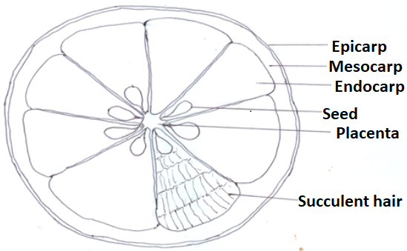
Correct drawing (1mark), Correct labels (1mark for each) (3 marks)

b. X – vitamin C¹
Y – Potassium/ vitamins C and K¹ (2 marks)

c. Make the specimen Y into a solution and place it in a test tube¹. Add a few drops of Benedict’s solution¹. Heat gently until it boils¹. Observe colour change¹. Brick red indicates presence of a reducing sugar¹. (5 marks)

END OF PROVISIONAL MARKING SCHEME

